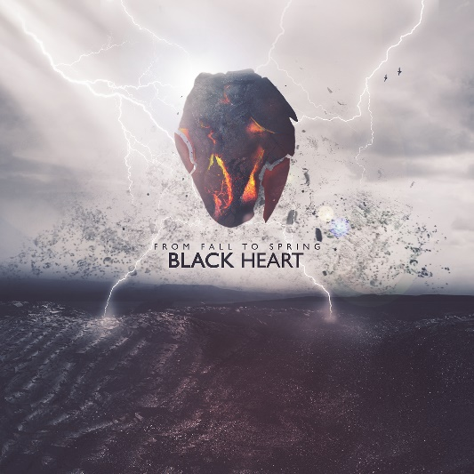
From Fall to Spring
»BLACK HEART«
SINGLE

OUT: SEPTEMBER 24th 2021

Line Up:  Line-up: | From Fall to Spring online:
Philip Wilhelm | Gesang / Gitarre  Lukas Wilhelm | Gesang / Gitarre  León Arend | Bass  Simon Triem | Keys  Benedikt Veith | Schlagzeug | https://www.instagram.com/from.fall.to.spring  https://www.facebook.com/from.fall.to.spring  https://twitter.com/ffts_ger  https://www.fromfalltospring.de

Made in Germany - The identical twins Philip and Lukas Wilhelm, both in charge of vocals and guitar, keyboard player Simon Triem, bass player León Arend and drummer Benedikt Veith are showing off the new standard within the scene with their first single 'Black Heart' via Arising Empire.
The new single 'Black Heart' explores a toxic relationship and the undying wish to end it. A unique approach to the nu metal genre, combining bone crushing 808’s with heavy guitars and catchy harmonizing melodies, crowned with high speed rap rhythms.
With this mixture, FROM FALL TO SPRING creates an unprecedented sound in the modern rock scene.
Working with producers Seb Monzel and head of Pitchback Studios, Aljoscha Sieg (ESKIMO CALLBOY - Hypa Hypa) FROM FALL TO SPRING are building a production which can easily hold its own among international acts while conveying a nostalgic vibe.

While the pandemic forced large parts of the scene into hiatus, FROM FALL TO SPRING remained unstoppable, generating a massive hype on all online platforms.
Starting a new sonic chapter, their single 'RISE' went viral on TikTok instantly becoming a milestone in a heartbeat not only in the bands career but in the whole German metal scene.
With the follow up 'BR4INFCK' the guys left no doubt that they have what it takes to make it to the very top. Despite being an independent release, the song still got listed on one of the biggest metal playlists on Spotify, arousing attention from all sides, new listeners as well as record labels and festival promoters alike. Now, having signed with Arising Empire , the band has found their perfect match and can’t wait to conquer the world.

________________________________________
MADE IN GERMANY
________________________________________

