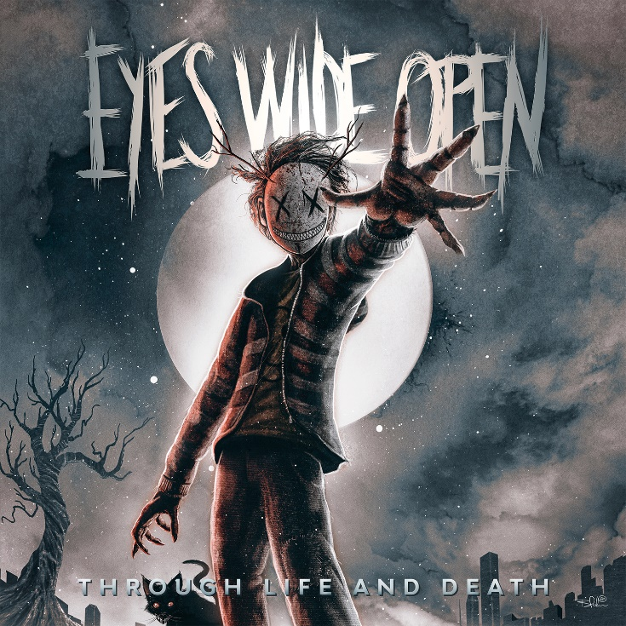

Eyes Wide Open
»Through Life and Death«

OUT: November 12th 2021

Line Up: | Eyes Wide Open online:
Erik Engstrand| Vocals  Kristofer Strandberg | Guitars  Jesper Lindgren | Bass  Lucas Freise | Drums | http://www.e-w-o.net/  https://www.facebook.com/Eyes.Wide.Open.SWE  https://www.instagram.com/ewo_swe/  https://www.youtube.com/EyesWideOpenOfficial

“The World is on Fire!”

Devastation spreads through the human society with pandemics, misleading information and corrupted leaders. Why can’t we change our ways?

Eyes Wide Open is a four-piece modern metal band based in Karlstad (Sweden).
Their music carries the torch from the Swedish melodic death metal scene, mixing it with modern sounds and new influences inspired from metalcore. Catchy melodies, heavy drumming, pumping rhythms and versatile vocals are merging into an own style of metal.
Toured with: 2 shows with Hatebreed, 2 Europe tours with The Unguided
The track Echoes on the new album we have featured both Richard Sjunnesson and Jonathan Thorpenberg from The Unguided.
The album is self produced by Erik Engstrand and Kristofer Strandberg and mixed and mastered by Kristofer himself. Recorded in their own ES Music Studio in Karlstad, Sweden.

1. World on Fire; (Instrumental intro to Devastation)

2. Devastation;
Us destroying ourselves and the earth with greed, depression and hate and how we all stand silent doin nothing about it, disconnected by a self made mask.

3. Fallout;
We need to change our perspective, see how deep down we really are and therefore change our ways to heal. Forge a new day.

4. Burn ’Em;
Burn down those dark thoughts, those festering inner demons we all carry and win the fight for your life.

5. End of Days;
Stranded on the black beach between life and death I struggle to find my way back to the light of life. (Inspired from Death Stranding the video game)

6. Through Life and Death;
Our lives are not a straight line, it’s rather an intense roller coaster through the deepest depths of despair to the highest mountains of joy. On this journey we will stumble, fall and it’s all about getting yourself up and rise up to the greater things in life.

7. Eraser;
A cold and dark winter depression that are blocking your energy, your will to seek out your dreams and hopes. Pray for the Eraser of the frozen to melt and mend your broken bones.

8. Brother;
Your best buddy that burned down your whole friendship and slowly became the fair-weather friend you really don’t want or need in your life.

9. Wildfire;
Misleading information spreads like a wildfire and it is truly dangerous in how it sways peoples minds and how easy and fast it spreads. All of us is victims to misleading information and it is so frustrating to hear people have opinions of matters they don’t really have a clear perspective on.

10. Echoes; (feat Richard Sjunnesson & Jonathan Thorpenberg of The Unguided)
Still in the upside down we are working to become better beings.
To find a place where we can grow like equals we have to try, fail and try again to discover our true selfs.
Our actions today will mark the future of ourselves and generations to come.
Our Echoes will never die.

11. Where Death Meets Paradise;
Deals with the loss of loved ones and the struggle for those who are left behind.
Dedicated to our dear friend Silas Jonsson and his family.
You will be missed!

12. Bridge to the Future; (Instrumental outro)
This serves as a bridge to the future, with a sad but still hopeful feeling towards new beginnings!

