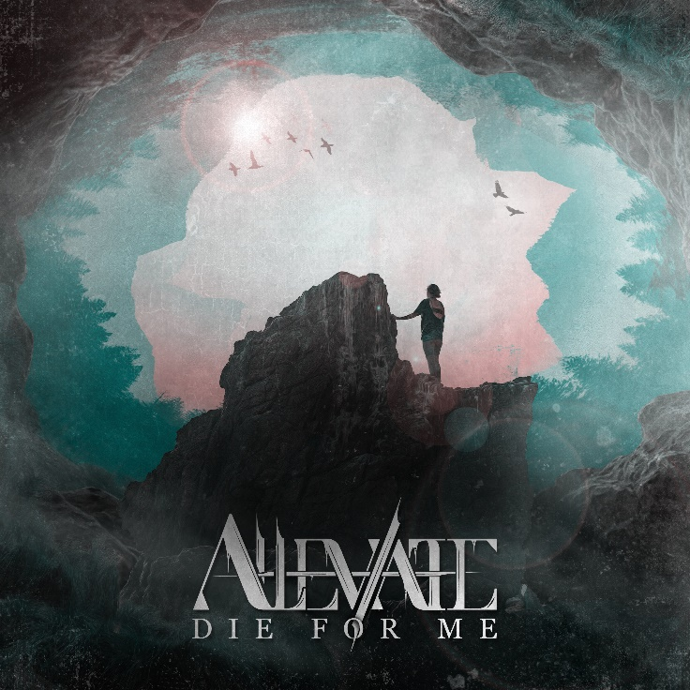

Alleviate
»Die For Me«

OUT: 2021, 21st May

Line Up:  Line-up: | Alleviate online:
Timo | clean vocals  Marius | shouts  Ramon| guitar  Marc | guitar  Yunus | drums | https://www.instagram.com/Alleviate.official  https://www.facebook.com/Alleviate.official  https://twitter.com/alleviateoffic1  https://www.tiktok.com/@alleviate.music
ALLEVIATE stands for strength that’s hidden deep inside of us all.

Supergroup ALLEVIATE consists of five successful musicians from five different bands in different genres of metal music.
Timo | clean vocals (Our Mirage)
Marius | shouts (Breakdown’s at Tiffany’s)
Ramon| guitar (The Evolutionist)
Marc | guitar (We Are Perspectives)
Yunus | drums (Time, The Valuator)
ALLEVIATE formed during the pandemic in 2020, and launched with first single ‚Die For Me‘.
The mix of five different perspectives makes ALLEVIATE very special. They combine the best of technical metalcore, deathcore, djent & post hardcore in one powerful and beautiful piece of art. Challenging guitar riffs, heavy breakdowns combined with deathcore vocals and catchy choruses are what makes ALLEVIATE stand out way above the crowd. All five musicians are highly accomplished, having proven themselves numerous times in previous and current bands. They have played hundreds of shows and are highly experienced live performers. As soon as the world returns to normal ALLEVIATE will hit the stage and take over the scene!
Their debut single 'Die For Me' is about personal experiences of the band members and reflects how to find your own strength during the darkest periods of life, and overcome deep depression and anxiety attacks.
The name Alleviate itself represents what the band basically stands for; giving hope and spreading a positive message into the world.
All Musicians have played hundreds of shows before in their lives and are highly experienced live performers. As soon as the world comes back to normal Alleviate is ready to hit the stage and take over the scene!
Their first single instantly brought the attention of the record label Arising Empire on the band and they signed a record deal shortly after. Alleviate are now working hard on new singles and a full length album together with their label.

