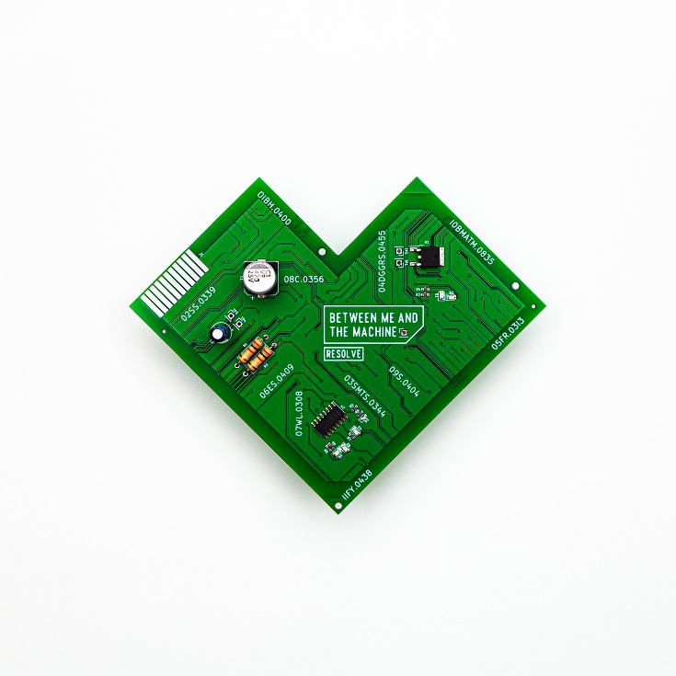

Resolve
»Between Me and The Machine«

OUT: November 26th 2022

Line Up:  Line-up: | Resolve online:
Anthony Diliberto | Vocals  Robin Mariat| Bass  Nathan Mariat | Drums | https://www.instagram.com/resolveofficial  https://www.facebook.com/ resolveofficial  https://twitter.com/resolveoff
The best things in life come to those who work.
Dipping your toes before jumping in at the deep end is something that will reward you in more ways than you realise. Those extra hours spent wondering, “what if?” will all be worth it when you figure out the best way to make it a reality rather than pushing too soon and being left to wonder, “what if we had done this differently?”
Resolve are a band that have been savouring every second of their journey so far and biding their time - observing, learning, building - and making sure that every single aspect of how they’ve wanted the band to function was fully realised before delivering it to the world. But now is their time to show you what they have been working on, and it is quite the spectacle.
Starting their journey back in 2016 after their previous projects parted ways and their intentions set on this being their forever band, vocalist Anthony Diliberto, bassist Robin Mariat and drummer Nathan Mariat have spent the last half a decade tinkering with the formula that feels the most suited to them. Making their first mark in 2017 with debut EP »Reverie« before following with standalone single ‘Carmela’ in 2018, it wasn’t until 2019 that they felt truly at home in their sound.
That was in the form of ‘Pendulum’, a collection of three songs that not only represented the beautifully bludgeoning and densely expansive sound that was resting in the back of their heads but that also found them appearing on Spotify’s New Core, New Metal Tracks and Kickass Metal playlists.

“It was with those three tracks that we really started to find what our sound was and how it was resonating with people,” Nathan explains. “We had been working so hard on everything already, but it was us simply figuring everything out. It just felt more natural than making a big jump.”
“At that time, it was about getting a community together,” Anthony nods.
“And because of our music suddenly getting to more people than had before, it all became much more serious.”
Though as the pressure to succeed increased, the band stayed cool and calm. The hard work had already been done, and the tools were in place to create something that truly represented who they were.
Made in the surroundings of Resolve HQ, a studio, rehearsal space and sanctuary built from the ground by the Mariat brothers, and crafted through the uncertainty and radical societal changes that came with the COVID-19 pandemic, the trio set about forging »Between Me and The Machine«, a record that perfectly encapsulates the chaos and callousness of the world we’re living in through Resolve's ambitious lens.
Recorded and mixed by Robin, the record is a richly textured and gutturally poignant collection of tracks that bat between white-hot riffs and shimmering ambience with the flick of the wrist.
From the gorgeously pummelling storytelling of ‘Emerald Skies’ and the melodic genius of ‘Seasick Sailor’ all the way through to the textured grit of ‘Cycles’ and haunting atmospheres of ‘Sing Me To Sleep’, it is as varied as it is visceral, showing off the bands attention to detail as much as their ear for an addictive chorus.
Though dig a little deeper, you'll find that the band delve even deeper into the emotional side of the times we live in. It’s an adventure, told through the eyes of a space explorer searching for a new world to inhabit after being overwhelmed by the level of technological advancement on his own planet and internal struggles he experiences along the way, into the deepest corners of the heart and soul, a search for tranquillity in a world controlled via buttons and wires. It’s about the balance between the self-doubt that we’re losing who we are as a society and the fear of what we would be without the means to live our lives as they are right now. More than anything, it’s about humanity, connection and community, three things that have inspired the band from the very beginning.
“It’s about finding your own place within a world that is becoming more and more dominated by machines,” Robin states. “We are part of the last generation that grew up without the Internet. Even though it feels natural to us, it’s also easy to still feel a little bit lost.”
When looking out for each other and soul searching feels more crucial than ever before, Resolve have put together a record that transcends borders altogether. They've created a universe littered with as much darkness as light and as much hardship as hope. »Between Me and The Machine« feels like just the beginning of a truly spectacular voyage to the stratosphere, but right now, it is the sound of a band making the most brutally honest and beautifully human music they can.

