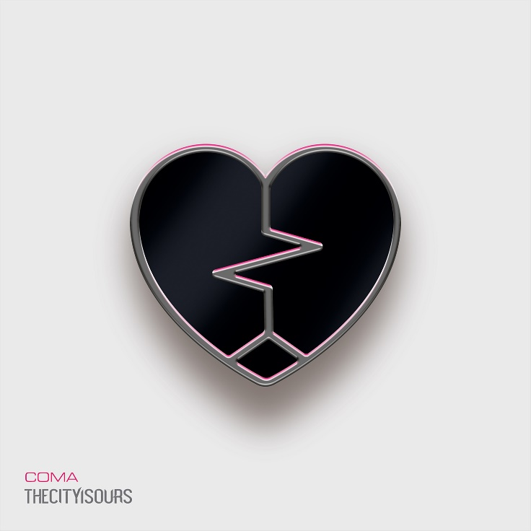
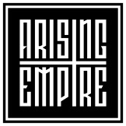

TheCityIsOurs
»Coma«

OUT: 2021, 22nd October

Line Up:  Line-up: | TheCityIsOurs online:
Oli Duncanson | Vocals  Mikey Page| Vocals/Guitar  Stuart Mercer| Guitar  Jamie Deeks | Bass  Louis Giannamore | Drums | https://www.instagram.com/thecityisoursuk  https://www.facebook.com/thecityisoursuk  https://twitter.com/thecityisoursuk
‘Digging deep and emerging from a time of great personal turmoil, the London five-piece have spliced together a debut album full of metalcore at its most infectious’ – Rock Sound

‘…a thunderously assured album dealing with loss and mental health that practices what it preaches on the subject of self-empowerment….LOW punches and soars in all the right places’ – Kerrang! KKKK

‘LOW explores a band’s journey towards self-betterment combining introspection with impassioned melodies and neck-snapping fervour’ – Metal Hammer 7/10

Since forming in 2015, this London based melodic metalcore 5-piece have been making strides in the alternative rock and metal scene. Extensive UK touring of their octane-fuelled live sets, along with the success of debut album »Low« (August 2019), which smashed into the top 5 iTunes metal charts, with a string of singles appearing in top Spotify and Amazon Music editorial playlists, has gained praise and recognition for CITY with peers and industry, and further cemented the loyalty and dedication of a growing army of fans.

2019 was a very busy year for the band, with appearances at a slew of UK festivals including Camden Rocks, Macmillan Fest, Burn It Down, Holloween, a fly in appearance at High Fives Festival in Sweden, a headline set in the Doghouse Tent at the revered Download Festival where an audience of 4000+ festival revellers got to witness CITY in full effect, and a sold out album release show at Boston Music Rooms in London.
Following the departure of long-standing vocalist Sam Stolliday the band unexpectedly found themselves in unknown territory, with a burning question – where do we go from here? 12 months on, the band are back with the introduction of new vocalist Oli Duncanson and ready to welcome a brand new era of THECITYISOURS.
“Oli has been a part of our team for a long time. He is a very well respected entity in his own right amongst the music scene, having toured as a photographer with bands such as Wage War, Oceans Ate Alaska, Our Hollow, Our Home amongst countless others. He was massively involved in bringing our creative vision to life on our first record and has toured with us a number of times, so the personal bonds were already very strong. We knew he had a voice in the locker. We’d seen snippets of his capabilities over the years, so when he registered an interest in becoming a part of CITY, we knew we had to explore it as an option.
We got him into the studio to demo a couple of tracks and clicked instantly. The vibe in the room was electric as soon as he opened his mouth. The power and raw emotion of his voice translated perfectly to the overall feel of what CITY was, but also opened up an exciting possibility to develop our sound in areas we had never explored before. We immediately knew we were dealing with something very special. The departure of Sam from the band left some very big shoes to fill, but we are confident that you won’t be disappointed with what’s to come from the new era of THECITYISOURS.” – Mikey Page

“The band and I have been good friends for years having worked for them or bands around them, be it on tour or creating their music videos for the last album, so in that sense I was fortunate to know the inner workings of the band before joining. I’ve always wanted to be part of a band but it’s always been something I was apprehensive to do as nothing previously ever seemed to feel right. I remember being shown some demos of some new songs prior to Sam’s departure and absolutely loving the direction and progression of the band’s sound so as soon as Mikey told me about the opening in the band, I knew I had to take a chance!” – Oli Duncanson

New single ‘Violent’ is the band’s first offering to feature Oli at the helm of THECITYISOURS and is a real nod to the angstier incarnation of the band.

“I think people have been a little cautious of bands like ours. We’ve always been a band that have bridged the gaps between genres and with its successes has often left people looking to others, perhaps afraid to admit they like what they’re hearing until its validated by one of their peers. ‘Violent’ is a line in the sand. It is the embodiment of our ethos of taking every element of our band to the next level and making a definitive mark with the dawn of a new era. As one of the heaviest tracks we’ve ever written, it starts hot and shows no sign of slowing down. Relentless angst from start to finish.
‘Violent’ is arguably our most honest account as a band to date. Betrayal was never something we’d really experienced before as a band, so dealing with events of this nature was a difficult but incredibly insightful process to experience. The progression from sadness to anger is always a difficult period to rationalise when contemplating the reasons for a relationship collapsing. In many cases, it’s clear that there are reasons or regrettable actions to contextualise a series of events. However, it does not mean that they hurt any less. This track lays it all out on the table, with a hope to providing some kind of solace for the pain, before picking ourselves back up and coming back, stronger than ever before.” – Mikey Page

‘Violent’ is set to be released on 26th March via Arising Empire.

“We are ecstatic to have joined the Arising Empire family, amongst a roster of so many talented bands. The team at the label have been incredibly supportive of our creative vision for this record and allowed us to spread our wings to create a collection of music unlike anything we have ever attempted before. Some of our biggest influences have been associated with this great team over the years, so we are very excited to see what the future has in store.” – Mikey Page

ALBUM
THECITYISOURS are notorious for combining emotionally driven lyrical content with a furious blend of Rock, Metal & Pop influences, and the Sophomore album »Coma« is no exception. Taking varied inspiration from the likes of Bring Me The Horizon, Don Broco and Wage War, through to artists such as Bruno Mars, Justin Timberlake and The 1975, the band have taken their philosophy for cross genre diversity to new levels entirely.

“COMA depicts a complex journey of self-discovery. A metaphorical life-after-death. I’d gone through an incredibly difficult time in my personal life which saw a number of important relationships very close to me falling apart. Sam had parted ways with the band and there were question marks around the future of CITY. I turned to the only thing I know for a form of respite from the emotional turmoil I was facing, picked up the guitar and started putting how I was feeling down on paper.
The variation of themes that came to fruition were in some ways surprising to me. There was an anger and bitterness I had never had the balls to put out in the open in such a direct manner before. I’d always been concious of keeping things subliminal through fear of how other people might perceive the material we were releasing. Our songs have always been written around things that have happened to us and how it’s affected us as people, but there was a new found honesty to this record unlike any previous attempts we had made as a band. It felt like the gloves had come off and we were free to do exactly what we wanted to do, without the limitations of judgement we had previously enslaved ourselves with.” – Mikey Page

There is an overarching presence of loss throughout the themes portrayed therough the lyrics on the record. A loss of loved ones, relationships, personal control and even a contemplation for a loss of life. However, juxtaposed against the fresh feeling, pop-centric musical arrangements that are interwoven throughout, this record breathes a balance of infectious radio stylised hooks that radiate an underlying positivity to an otherwise dark concept through the lyrical content.

“We have always been a band that has worn our hearts on our sleeves. We have never been afraid to speak about or show our emotions in the public domain and this record is a true extension of that ideology. There is a toxicity in some areas of society that often condemns the expression of emotion, particularly in men & boys, as weakness.
These songs tell the story of some of the most difficult times of my life. I wanted to write a record that outwardly showed the audience that it’s okay to cry. It’s okay to say you’re not okay. I hope people are able to relate to this record in a way that they can take from it and hopefully in turn, provide a network for people to connect with each other and make those dark days a little brighter.” – Mikey Page

In collaboration with Oz Craggs at Hidden Track Studios (Neck Deep, Mallory Knox, Feed The Rhino) this latest work has developed a fresh maturity in sound, through the crossing of genre lines and limitations.

“With so much change in and around the band, we needed somebody we trusted to help us develop a new sound that paid homage to everything people have grown to love about CITY, whilst simultaneously closing the door on the past and embracing a new era of our band. When we decided we were going to put together a new record, it was never in doubt that we would be returning to Hidden Track to work with Oz again. As a long time friend of the band and producer of our previous work, he had an insight into how we wanted to experiment with our previous formula and create something that felt like a positive evolution of CITY.
We wanted to make a record that didn’t sound like anybody else. Something to lay down the gauntlet and show that just being present wasn’t going to be enough this time around. We weren’t just here to be a passive part in the music scene, but to assert ourselves within it. Following meticulous discussions regarding the direction we wanted to pursue, Oz encapsulated our vision as trying to marry the heaviest of Modern Metal production, with a slick pop vocal production that wouldn’t sound out of place amongst either genre. This cemented the feel for exactly what we were aiming to achieve and perfectly describes the final product we achieved. I believe this is sonically the best work we have produced to date and I am excited to show the world what we have to offer.” – Mikey Page

“Prior to recording with Oz I didn’t really have any experience tracking vocals apart from doing a cover here and there with some friends. I ended up demoing the tracks for this release remotely, using a cheap USB mic and free audio software barely having a clue to what I was doing so going to Hidden Track Studios was an awesome experience. I truly feel that Oz brought out the best of my potential and we can’t wait for people to hear what’s been produced!” – Oli Duncanson

