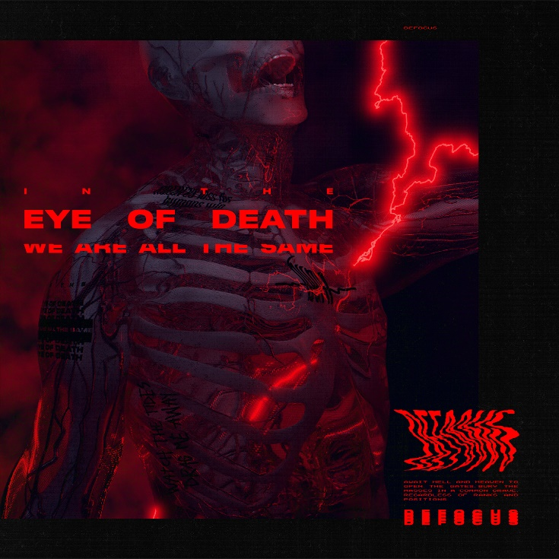

DEFOCUS
»In The Eye Of Death We Are All The Same«

OUT: 2021, 2nd July

Line Up:  Line-up: | DEFOCUS online:
Simon Müller | Vocals  Jeffrey Uhlmann| Guitar  Marcel „Bambam“ Heberling | Bass  Jonas Mahler | Drums | https://www.instagram.com/defocus.band/  https://www.facebook.com/defocus  http://defocusband.com/
With the upcoming release of »In The Eye Of Death We Are All The Same«, DEFOCUS enters the Metal scene with a record full of heavy, low tuned songs, where they dive deep into the progression of the world we are living in and how we are all affected by it.
Founded by Simon Müller, Jeffrey Uhlmann, Jonas Mahler and Marcel "Bambam" Heberling, DEFOCUS spent time making music together before coming to light in early 2019, instantly proving their worth in the scene with their energetic live shows.
Exceedingly low guitars and driving rhythms, paired with dark and ambient melodies create a melancholic atmosphere that characteristically stands for the thrilling sound represented on their new record. With songs like ‚Thought Of A Vision‘ or ‚Can You See Me?‘ DEFOCUS shows what they are capable of, combining their very own diverse style and aggressive vocals, to create catchy, yet energizing heavy songs to delight fans of different metal genres.
Faced with the global COVID-19 pandemic, DEFOCUS got to work on their material through countless extensive late-night online sessions, allowing every member to contribute their individual ideas and emotions.
„I remember that when we started to write all these songs, everyone was on the same page from the beginning and we knew exactly which direction we want to go, but at the same time everyone took inspiration from different sources. Seeing all these songs finally come together in the end makes me super happy, because the writing process and everything around it really defined who we are as a band and resulted in a record everyone in the band can 100% identify with.“ - Jeffrey
While the pandemic was still in full swing, all tracks were recorded remotely from home while Christoph Wieczorek from Sawdust Recordings took care of the mix and master, that really matches the crushing and impulsive sound of modern metalcore.
„Await hell and heaven to open the gates, bury the masses in a common grave. Regardless of ranks and positions, IN THE EYE OF DEATH WE ARE ALL THE SAME“ from the track ‚Common Grave‘ perfectly represents the overall theme and mood of the album.
„Mankind still tends to be living an egoistic lifestyle and there’s probably a reason why we’re not considered as ‘social’ beings. With this being said while the world turns upside down and everything seems to get worse and worse, everyone will die alone in the end.“ - Simon

