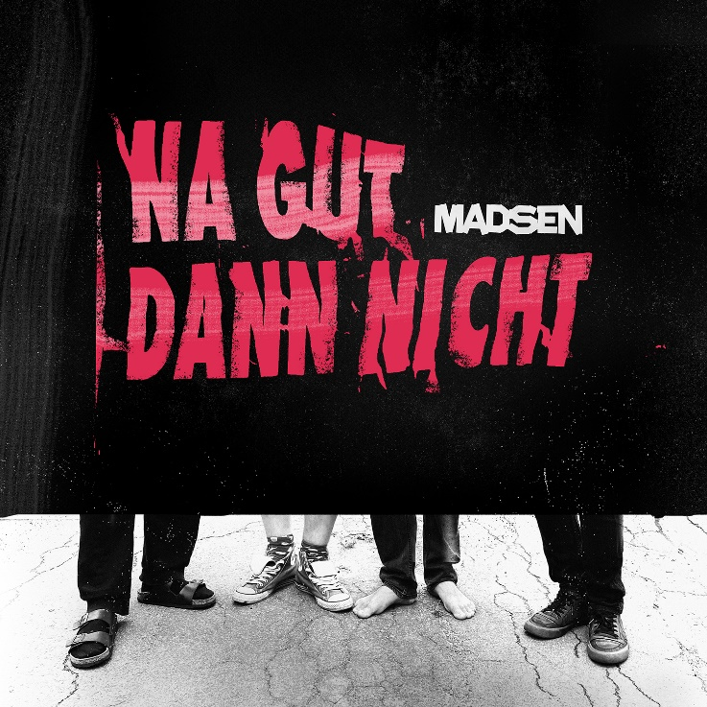

Madsen
»NA GUT DANN NICHT«

OUT: 2nd October, 2020

Line Up:  Line-up: | MADSEN online:
Sebastian Madsen | Gesang / Gitarre  Johannes Madsen | Gitarre  Sascha Madsen | Schlagzeug / Gesang  Niko Maurer | Bass | www.madsenmusik.de  www.facebook.com/madsenmusik  www.instagram.com/madsen_official  https://twitter.com/madsenmusik

»NA GUT DANN NICHT«
MADSEN DROP PUNK ALBUM
First single in August, the album will be released by Arising Empire / KEEK Records in October

In the middle of the corona pandemic, MADSEN singer Sebastian Madsen woke up one morning and the first thought that shot through his head was: Punk!
“Actually, we had fully planned this year with Madsen: We would have gone on tour in April, after which that we wanted to record our new album, which has already been written and pre-produced. But then Corona came.” he says. “In the middle of March I fled to Wendland with Lisa. At the beginning we cleaned up our rehearsal room thoroughly, then wrote some songs for other artists. And at some point I suddenly felt like punk."
First he bought the RAMONES' debut album on vinyl and listened to it up and down, then he started writing songs himself. Not only Sebastian, but also the rest of the band had so much fun with the songs that MADSEN now release a punk album with »NA GUT DANN NICHT« - spontaneously created in the here and now.

You have to say: Punk is firmly rooted in the band's DNA. “At the beginning of the nineties there was a big punk scene here in Wendland and the first band I founded with Johannes was punk. Our role models were slime, daily terror, toxoplasma or phlegm.” Sebastian said. "On the first Madsen album you can still hear the punk influence very clearly, over the years it has taken a back seat."
But now, 15 years after the release of MADSEN's debut album, he made his way loudly and purposefully back into the rehearsal room and into the studio in the middle of the Corona period, which was characterized by frustration and boredom.
MADSEN recorded the album in just two weeks in their home studio in Wendland. The joy of making music together was clearly in the foreground. “Our days looked like this: Sitting in the garden together, texting, recording, drinking beer and finally listening to the day's work.” says Sebastian. “Otherwise I always write alone and I have to say: We have never worked as a collective as well as with this album. That's why there is so much humor and completely different facets in the songs."

In fact, everyone is allowed to go to the microphone and everything is allowed. After MADSEN had to be told in the opening piece ‘Na gut dann nicht’ that punk was dead, he was immediately revived in 'Herzstillstand'. Then angry Oi-Punk meets Blitzkrieg bop-like hooks, heavy metal riffs are followed by polyphonic Bad Religion choirs. As befits punk, Madsen screams the frustration from their soul. ‘Wenn du am Boden liegst’ is an appeal for more empathy and compassion towards refugees, ‘Protest ist cool aber anstrengend’ meanwhile describes in a humorous way what it is like to have to choose between political engagement and mowing the lawn. Incidentally, the two most angry songs were written by keyboardist Lisa Who: ‘Alte weiße Männer’ is a reckoning with the patriarchy and ‘Supergau’ is a swan song to humanity. But there are also ironic and highly amusing moments - from the burp in the lockdown single ‘Quarantäne für immer’ to the anthem via ‘Trash TV’. And then there's the outro by author Benjamin von Stuckrad-Barre, who comes to the conclusion: "Maybe that's the beginning - maybe that's the end, Madsen."

In short: The fun MADSEN had with the recordings resonates in every track on the album. »NA GUT DANN NICHT« sounds intense, authentic and yet as light-hearted as it came about. By the way, to make the punk ethos perfect, everything is DIY on the album. MADSEN founded their own label KEEK Records for this and upcoming release - on which other artists may later appear. And the music videos were all created in Wendland on their own. So MADSEN take us in the clip to 'Quarantäne für immer’ to their old children's room. An album has never been closer to MADSEN and the current time than this.

