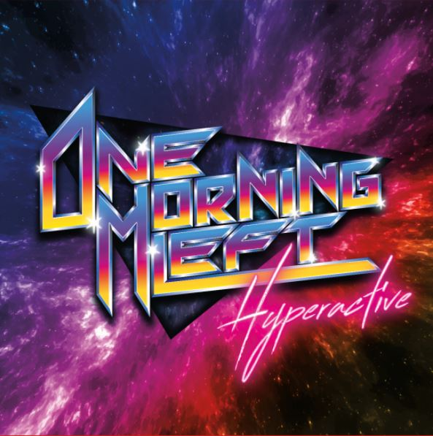

ONE MORNING LEFT
»HYPERACTIVE«

OUT: May 21st 2021

Line-up:
One Morning Left is: | ONE MORNING LEFT online:
Mika Lahti - Lead Vocals  Leevi Luoto - Guitar & Lead Vocals  Touko Keippilä - Keyboards & Backing Vocals  Miska Sipiläinen - Bass & Backing Vocals  Niko Hyttinen – Drums  Tuukka Ojansivu - Guitar & Backing Vocals | http://bit.ly/OML-Facebook  http://bit.ly/OML-Instagram  http://bit.ly/OneMorningLeft  http://onemorningleft.com

With their fourth album, the Finnish metalcore act ONE MORNING LEFT ends a five-year-long pause in releasing new material. On »HYPERACTIVE« the group begins a whole new chapter in their story, drawing inspiration from retro electronic- and video game music, as well as 80’s hard rock, while staying true to their heavier roots.

Changes are happening not only in the musical style, but also in the lineup. Returning from the cast of 2016’s “Metalcore Superstars” are frontman Mika Lahti, singer-guitarist Leevi Luoto and drummer Niko Hyttinen. Additional firepower is provided by new faces Tuukka Ojansivu on guitar and Miska Sipiläinen on bass guitar, as well as the return-to-form of keyboard player Touko Keippilä from the band’s original “Panda <3 Penguin” lineup.

The album shapes up to be the artistic peak of One Morning Left's musical "blood mountain": epic lyrics carried by Luoto’s soaring vocal melodies, contrasted by the distinctive, gritty sound of Lahti, all accompanied by breathtaking keyboard leads, blisteringly fast guitars, masterful bass riffs and feverish drum parts.

The recording process of »HYPERACTIVE« was done according to the band’s “Do-it-yourself'' principles. The guitars, bass guitars and drums were engineered by Tuukka Ojansivu, with Touko Keippilä taking care of the keyboard and vocal recordings. Much of the groundwork was laid out in Ojansivu's small apartment, using only a small Focusrite sound card and an Axe-FX preamp-processor with some near-field monitors. Mixing- and mastering engineer Rami Nykänen was a match made in heaven, glueing the parts together, while adding some crucial personal touches. “Our days were spent fighting technical difficulties, setting up instruments, measuring input latencies, making coffee, acquiring snus, listening to mixes, fetching energy drinks and batteries for the Microkorg and recording yet another layer of backing vocals... And it was all well worth it!” guitarist Tuukka explains. Vocalist Mika Lahti has something to say as well: “This is the first time in the band’s career that I felt like everything was done to perfection, with special thanks to our practice space’s super dry AC to amp up those vocal takes!” All music was composed by Leevi Luoto, often joined by Ojansivu and Keippilä. The lyrics were written by Luoto.

The title, “HYPERACTIVE”, reflects both the musical and the lyrical content on the album, which can be seen as a critique of modern life. Attention spans are shortened by a flood of information, making everything and everyone hyperactive. The lyrics deal with such topics as depression, mania, overcoming addiction, love, hate, and stress. These issues are observed through a prism of sci-fi and dystopian themes running throughout the album. “I was heavily inspired by old school heavy metal lyrics by bands such as Judas Priest and Iron Maiden, as well as sci-fi movies and TV-series, like Black Mirror, to use fantasy as a vessel to process such heavy topics,” lyricist Leevi Luoto notes. The songwriting process was a long and challenging one, with some tracks being started as early as 2017, but remaining unfinished until the band was strengthened by bass player Sipiläinen and keyboardist Keippilä in late 2018. After that everything seemed to just fall into place: the band’s new, now recognizable sound, was found quickly and the process sped up with the album being finished in early 2020.

The album starts off with a bang with “Ruby Dragon”, a song about self-improvement, overcoming depression and becoming the best version of yourself. “Mika wanted a song about the board game ”Labyrinth” so I adapted that to the themes above and had a great time writing this, even though the inspirations are.. heavy,” Luoto explains. Keyboardist Touko Keippilä continues: “Ruby Dragon was the culmination point in the album writing process, as it perfectly encapsulates what we aspire our new musical style to be like. Groovy, heavy riffs and clean, glistening synthwork providing a platform for the two vocalists to deliver their lines with a raw and wild energy.”

The following track, “Neon Highway”, is a hyperactive love song full of pure chaos and fury, thoroughly resonating with the album title. As told by Leevi Luoto: “This is a straight up love song. MAD love. Also functions as the landscape-painter of the album, describing the world we’re singing about.”

Continuing the barrage of fast-paced tracks is party anthem “Sinners Are Winners”, a love letter to 80’s hard rock. Lyrically the song is a parody of the party hard lifestyle and rock’n’roll clichés. “I f****ng love the 80’s and wanted to mix those guitar mannerisms with metalcore, creating one of the most fun songs to bang your head to,” Luoto says. Making a guest appearance with a face-melting guitar solo is producer/guitarist Joonas Parkkonen (Santa Cruz, Lost Society, Apocalyptica).

Presenting a heavier and darker side of One Morning Left, “Drowned God” offers a unique take on modern metal music. As the first song written for the album, with some parts dating as far back as 2008, the lyrics are heavily influenced by singer Leevi Luoto’s childhood. “I was super bullied as a kid, the feelings and power-fantasies of those days were the inspiration when writing this,” he explains. Taking a completely different direction is “CREATVRES”, a danceable rock song about unity and empowerment. Groovy drum beats, heavy guitars, and bright synths create a solid backdrop for the two vocalists to shine over. “A gem of modern music,” as remarked by bassist Miska Sipiläinen, “CREATVRES” is definitely the one of poppier tracks in the band’s catalogue. “Can’t wait to see which ice hockey team adopts this as their theme song!”, Keippilä adds.

Bringing the album back to it’s speedy tracks, “Live, Laugh, Love” takes a stab at the facade of fake smiles on social media. The breathtakingly aggressive and emotional delivery of Mika Lahti takes center stage, supported by a bombardment of guitar-shredding and drummer Niko Hyttinen’s blast beats. “Full blast, no chill, just punches you in the face. That’s what I like,” Hyttinen summarizes.

With “Ruthless Resistance” ONE MORNING LEFT takes the listener on an adventure through a landscape of sci-fi and fantasy clichés in an effort to save a crew member from peril. Starting out with Ojansivu’s thrash metal-inspired guitar riffs, the song builds up to a monumental crescendo with the entire band joining up in a grand chorus. “We wanted to capture the childlike, adventurous feeling of this song. The lyrics are about friendship and trying to destroy the ”big evil” in a very Star Wars-ey kind of way” Luoto says.

Adding to the wide variety of musical styles heard on the album is “Downfall”, a funk and nu-metal inspired track, full of haunted house-esque keyboards, screeching guitars, Sipiläinen’s groovy basslines, a guest appearance by DJ Massimo and even a verse featuring underground rapper OG Ulla-Maija. The song, inspired by the graphic novel “The Killing Joke”, describes a person’s struggle coping with constant stress, depression, and anxiety. “The lyrics on this one hit the closest to home for me. Having suffered from anxiety and depression, screaming along to ”Will I ever be whole again?” sends a shiver down my spine every time,” Touko Keippilä comments.

With “Worry Less, Dance More” the band’s love for fast-paced progressive metal and alt-rock really shines through. “Probably the most fun song to play on the album. Fast tempo, absolute killer riffs, precise picking, total perfection!” Miska Sipiläinen narrates. Mika Lahti continues: “This has been one of my favorites since the demo stage. Leevi’s very topical lyrics are a take on today's influencer culture: everyone considers themselves a “Cyber-Gandhi”, but few are able to live up to their projected standards.”

Acting as the album’s grand finale, the titular “Hyperactive” presents a ferocious amalgamation of hardcore riffing and Keippilä’s synthwave arrangements. The song squeezes out the last drops of energy one has left after listening to the album. “When creating the track, it became very clear that this will be the last song on the album. “Hyperactive” is fabricating an illusion of closure, while being a powerful and entertaining cliff-hanger for our upcoming material,” guitarist Tuukka Ojansivu illustrates. Absolutely packed with immense frustration and sadness, the album’s conclusion functions as a yang to “Ruby Dragon”’s yin, summing up the album both musically and lyrically. The vocalists’ intense delivery grants authority to the song’s message of self-examination and rebellion.

With »HYPERACTIVE« released in May of 2021 by ARISING EMPIRE, ONE MORNING LEFT looks to add to their growing global fan base. Having gathered extensive live performance experience playing countless shows in Finland, touring mainland Europe, Russia, and the Baltics, and even performing in places such as Iceland and Japan, the group is planning on taking their entertaining and energetic live show on the road in the near future.

