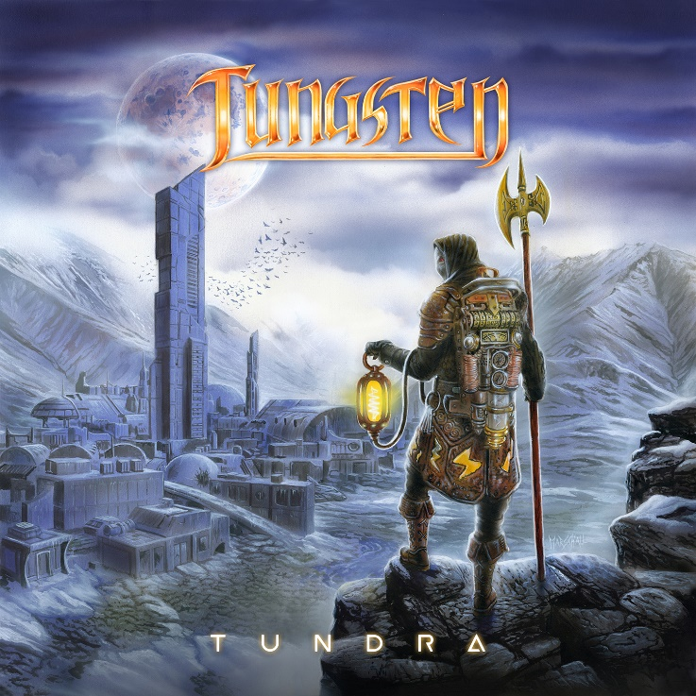
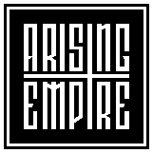

Tungsten
»Tundra«

OUT: Nov 20th, 2020

Line Up:  Line-up: | Tungsten online:
Mike Andersson | Vocals  Nick Johansson | Guitars  Karl Johansson | Bass, Screams & Keyboards  Anders Johansson | Drums | https://www.facebook.com/tungstenband  https://www.instagram.com/tungsten_online

Swedish metal band TUNGSTEN is back with their second album entitled »Tundra«.

After the success of debuting album, »We Will Rise« (released worldwide on September 20, 2019) Tungsten is back and ready to release their second album to the world entitled »Tundra« on the 20th of November 2020.

The music on »Tundra« follows the musical direction TUNGSTEN had on »We Will Rise« but with more of everything. The listener will recognize the characteristics of TUNGSTEN but the sound is darker and from time to time more epic than before. The blend-in of catchy metal is still there.

Karl says: “The diversity is still definitely there just like on the first album. But this time around to quote my dad’s boss from the 80s ‘MORE IS MORE’!”

The lyrics on TUNDRA are a lot about time. They are still down to earth dealing about natural things that common man might relate too. There’s also fiction and mysterious stories about Volfram, the man on the album covers who is the guardian of time and balance, the traveler between time and space and different dimensions. On »Tundra« he has travelled from a world in a past time with castles, fairies, and knights to a future world which is a city after its fall, ending up in the middle of an icy tundra where almost no man can survive the freezing cold climate.

Mike: “We are so eager to release TUNDRA, a true melodic, heavy piece of metal! We are truly excited! Considering we couldn’t tour with WE WILL RISE we are now more than ready to hit the road in 2021.”
Nick adds: “We’re already confirmed for SABATON OPEN AIR in August 2021.”

RECORDING OF TUNDRA
The recording of TUNGSTEN’s second album »Tundra« started in late 2019 with drums at Der Bunker followed by bass, guitar, growls and keyboard recordings at Harm Studios. Mike finalized everything with his vocal recordings in February 2020.

Once again highly skilled guitar player Nick Johansson took care of the production and mastering duties to complete the album at Harm Studios. This time around TUNGSTEN invited legendary keyboard player, who is Anders’ brother, Jens Johansson (Rainbow, Stratovarius) to record a keyboard solo on one song ‘Here Comes the Fall’. This marks the first time where Anders, Jens and Anders’ sons Nick and Karl officially appears on music together.

Once again artist Andreas Marshall was hired to create the album cover.

Anders: “Andreas is a true artist and gentleman. He really listens to suggestions and have an open mind to do his best ´creating the cover. Pure art. His paintings are truly enchanting, and we are very grateful to have him creating our album covers and making Volfram somewhat alive.”

In May 2020 TUNGSTEN hooked up with Jose Pasqual and his team at film production company 11 FRAMES in Gothenburg to shoot the first music video for »Tundra« and the song was ‘King Of Shadows’. A song that was selected unanimously by the band and record label. It’s a true live-banger and very catchy with strong hooklines.

TUNGSTEN BAND
TUNGSTEN was formed in 2016 by drummer Anders Johansson (Hammerfall, Yngwie J. Malmsteen’s Rising Force, Manowar) after his sons Karl and Nick Johansson had let him listen to some songs they had composed together. Soon thereafter Mike Andersson was added to complete the band.

Anders Johansson is one of the most skilled and experienced drummers in the metal world with a background from listening to Deep Purple and Rainbow. He also has strong influences from jazz and he plays upright bass.

The musical talent was passed on to Karl and Nick who praises bands like Rammstein and Meshuggah. Being from a later generation, they bring modernity and current trends to the music.

Mike enjoys a wide variety of bands, from Bee Gees to Meshuggah, and listens a lot to different singing styles which contributes to the melodic and varied singing in TUNGSTEN.

ARISING EMPIRE
Arising Empire and Markus Staiger, who is responsible for the success of many bands, loved the album »We Will Rise« and a contract between Arising Empire and TUNGSTEN was signed in spring 2019. Three videos/singles later the debut album »We Will Rise« was released (September 20th, 2019). The album received great reviews from magazines worldwide and was praised by fans to be the “missing piece” in metal. The TUNGSTEN fanbase is growing fast throughout the world!

The second album entitled »Tundra« will be released on 20th of November 2020. Once again Markus Staiger and his partners at Arising Empire goes full throttle believing in this album that takes everything one step further. »Tundra« will be another bomb to please the metal fans all over the world!

