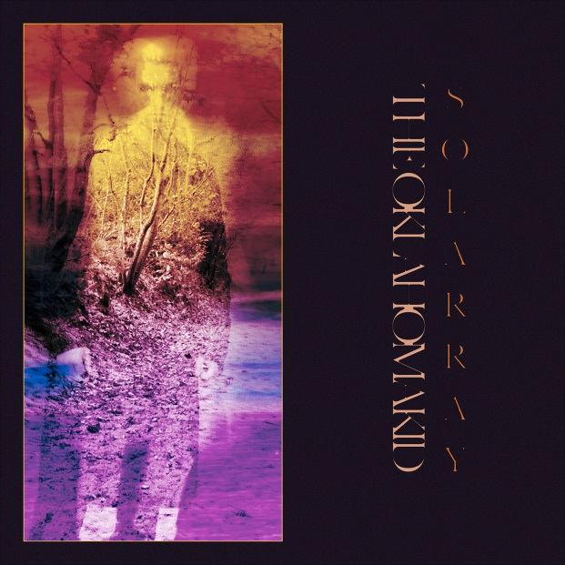

THE OKLAHOMA KID
»SOLARRAY«

OUT: September 13th 2019

Line Up:  Line-up: | THE OKLAHOMA KID online:
Tomm Brümmer | vocals  Fred Stoelzel | guitars  Andreas Reinhard | guitars  Robert Elfenbein | bass  David J. Burtscher | drums | https://www.facebook.com/theoklahomakidofficial/  https://www.instagram.com/theoklahomakidband/  https://twitter.com/tok_official?lang=de
The Oklahoma Kid stands for breathtaking modern metal that bridges the gap between technical intricacy and energizing rhythms. Since their formation in 2012 the band - consisting of David J. Burtscher, Fred Stölzel, Robert Elfenbein, Tomm Brümmer and Andreas Reinhard - has consistently pushed the envelope and have established their foundation in the German metal scene.

Their 2014 debut EP »Fortuneteller« impressed the scene with their very own blending of genres:
„Fortuneteller encapsulates the very essence of the post-hardcore and metalcore genres, but effectively intertwines tech metal and crushing djent riffs into a very solid effort.” - Kenny McGalem, Bandcamp

Already one year later the band added a second EP »Doppelganger« to their catalogue for which they hired acknowledged producer Aljoscha Sieg (Eskimo Callboy, We Butter The Bread With Butter, Nasty) and solidified their sonic vision. The band's signature bouncing grooves and futuristic synthesizers were completed by catchy hooks and sing-alongs.
The band teamed up with visionary director Pavel Trebukhin (ALAZKA, Stick To Your Guns, ANNISOKAY) to create a unique music video for their hit-single ‘Scharlatan’, for which they would receive the national PopFish Music Video Award.

The Oklahoma Kid toured the country with renowned acts such as Stick To Your Guns, Carnifex, Evergreen Terrace and Hatebreed and electrified crowds with their passionate, relentless performance.
Persistently, the band started producing their debut full-length »SOLARRAY« in late 2017. »SOLARRAY« doesn't adhere to genre formulas displays The Oklahoma Kid's full sonic scope and capabilities. The songs vary between huge wall-of-sound arrangements and fragile melodies. Vintage aesthetics meet modern perfectionism; abstract conceptualism meet sophisticated arrangements.
The very essence of this vision is not only encapsulated in sound but also in the delicate lyrics: Bleek existentialism, social commentary and a reflection of the self are the core themes that are explored on »SOLARRAY«.
Every single song on the record reeks of passion and commitment and makes for a unique listening experience.

The Oklahoma Kid are no longer an insider tip and a force to be reckoned with. No matter if live at a festival or on the record player in the living room; The Oklahoma Kid will change your perception of what metal is capable of.

