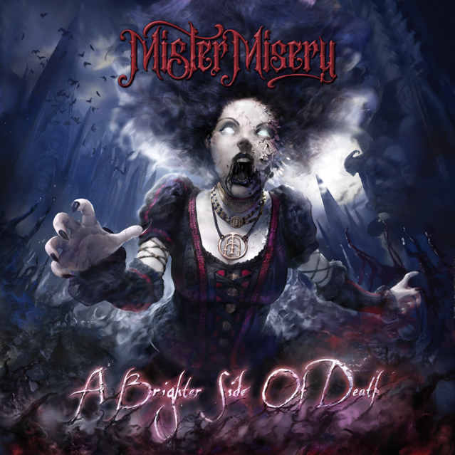

Mister Misery
» A Brighter Side Of Death «

OUT: April 23rd 2021

Line Up:  Line-up: | MISTER MISERY online:
Harley Vendetta | Vocals/Guitar  Alex Nine | Lead Guitar/Backup Vocals  Rizzy | Drums/Backup Vocals  Alex Alister | Bass/Backup Vocals | https://mistermisery.com/  https://www.facebook.com/mistermiseryband/  https://www.instagram.com/mistermiseryband/  https://www.youtube.com/channel/UCTAwUXURrJZP9z65Hv64NBA/videos

MISTER MISERY, spawned from the hollowed parts of Sweden in February 2018, is a modern horror metal band consisting of 4 unalive creatures, with the will to spark a flame in your restless souls!
By blending high energy riffs combined with anthemic choruses, their sound borders the genres of both old school rock n roll, sleaze and aggressive modern metal, all mixed delightfully together to create the unique sound that characterizes MISTER MISERY today.

After the pace-setting release of their praised debut album »Unalive« in 2019, the band has not slowed down, despite the fact a global pandemic crushed schedules, MISTER MISERY kept busy during quarantine, writing new breathtaking material, while still releasing numerous compilations for their fans in the meantime.

MISTER MISERY just launched the pre-order for their second full length album »A Brighter Side Of Death«, set to be released in April 2021.

“We feel super excited to finally release the pre-order for our brand new second album “A brighter side of death”
It’s been one hell of a ride to say the least, and we have pushed our musical abilities to the maximum on this one!
We look very bright on the future for this band and we have never looked more forward to stepping onto a stage again in 2021!”

The first single of the album: ‘Ballad Of The Headless Horseman’ combined with a mind-blowing music video released on December 11th. The single marks a milestone for the band and opens up the next chapter of their horror story! Stronger, scarier and more diverse than ever.

“Ballad of the headless horseman was absolutely the peak of making this album for me. I was in a great state of mind writing this song and it took me back to the first album Unalive where every riff, every melody and lyric came together in one night. Those usually turn out to be the best songs.” HARLEY

“I remember when Harley sent me the first version of Ballad Of The Headless Horseman, and I was immediately blown away! Just as with “‘My Ghost’, Harley had just created something huge out of nowhere. It was perfect and I knew the rest of the album was gonna be more massive than we’ve ever sounded before!” ALEX

The band will march through Europe on their 2nd headline tour soon, while booking more shows for the year with the ambition that the world will be back on its feet and ready to go wild again!

»Unalive« was the birth.
»A Brighter Side Of Death is the rise of MISTER MISERY!

