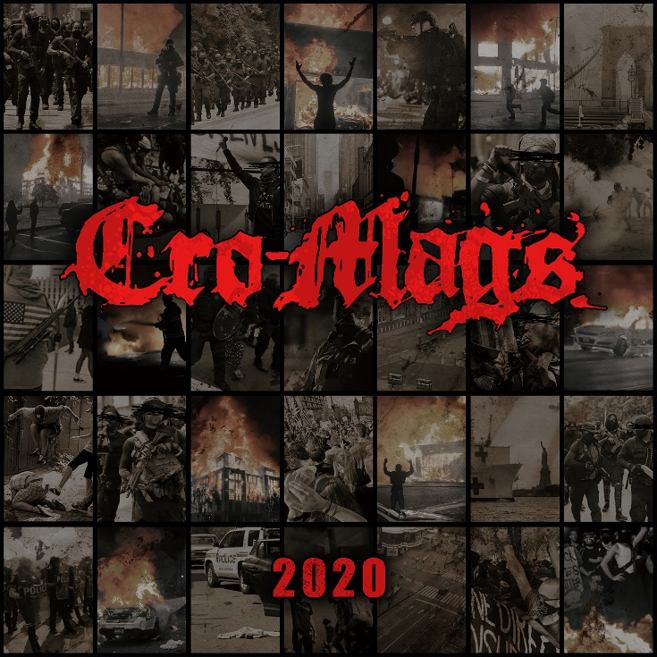

CRO-MAGS
»2020«

OUT: December 11th, 2020

Line Up:  Line-up: | CRO-MAGS online:
Harley Flanagan | Vocals & Bass  Rocky George | Guitar  Joe Affe | Guitar  Garry ‘G-Man’ Sullivan | Drums | https://www.facebook.com/realcromags  https://www.instagram.com/realcromags  https://twitter.com/realcromags

CRO-MAGS 2020 plays out more like a time-capsule playlist to the year rather than a group of individual songs.

The record itself is unintentionally 20 minutes and 20 seconds. CRO-MAGS founder and kingpin Harley Flanagan explains, “Just by coincidence we recorded 20 minutes and 16 seconds of music, so we simply added a few seconds of real-world chaos. The album cover is meant to look like a calendar - 7 squares across, with one picture from 2020 per day. Inside the booklet there are 12 pictures, one for each month of 2020; and the back is a shot of something I have never seen before in my life - a totally empty New York City. Corona Virus, quarantine, empty streets, brutality, burning buildings, violence and destruction: 2020 is a year none of us will ever forget.”

The first song, ‘Age of Quarantine’, is about how the year started off, and the global quarantine that had us all locked in our homes, isolated, not working and afraid to come in contact with other humans for fear of the virus. At the end you hear NYC's 7:30pm healthcare worker support rally where everybody would cheer and make noise from their apartments and down in the streets. I just hung my phone out the window and recorded it.

‘2020’ is about the overall year - all of the madness and how insane it has been for everyone.

‘Life On Earth’ - explains where we’re at 11 months later - the global health crisis and the continued collapse of societies and economies.

‘Violence And Destruction’ - addresses what we are seeing all around us now in this country. It forces us to ask a simple question: “If you don’t agree with someone, does that justify violence against them?” What if it was your father, your brother or your children on the other side? I myself have people I love dearly who I disagree with on many different topics. Does that make me love them any less? No, and I try to keep that in mind when I don’t agree with others in general. Until people learn how to communicate, there’s not much hope for anyone.

‘Chaos In The Streets’ - self-explanatory regarding mob violence and self-defense. The beliefs of others no longer matter when you are defending your life or the lives of your loved ones.

And ‘Crofusion’ wraps up the year. It was part of a 20 minute freestyle jam we did at the end of the recording session. It's just total musical chaos ending with the sounds of riot, and felt like a perfect expression of this year. It could be likened to a fusion-type assault in the vein of Lenny White or Billy Cobham's early records- but done hardcore style…total madness and chaos. It's definitely more funk/fusion than hardcore. Cro-Mags + Confusion = Crofusion!

CRO-MAGS were set to kick-off a world-wide tour starting in NYC on March 15th (with Body Count at Webster Hall). Within 48 hours of the show, quarantine went into effect and the state’s governor and mayor banned all public gatherings. Flanagan goes on to disclose, “We pooled our resources and put together for what was one of the first, if not the first, live quarantine shows on March 15th.” Seen by hundreds of thousands of people worldwide, the CRO-MAGS ‘Quarantine Show’ was the beginning of trying to turn an unfortunate situation into something positive. “(Drummer) G-Man was stuck in New York for seven months because of the travel ban, so we started writing songs, and as soon as we were able to get into the studio we started tracking,” Flanagan adds. Recorded at Steve Zing's (Sam Hain, Danzig) newly launched Trick or Treat Studio, and brought back Arthur Rizk who produced the band’s first full length album in 20 years, 2019’s In The Beginning.

“Bad things are always going to happen, we have to learn how to pivot and adjust when they do,” Flanagan points out. “Our show got canceled, so we did one online for the world to see. Our tours got canceled, so we recorded an album.”

“After months of confinement, with a political climate unlike any I have ever seen in my lifetime, many have lost their minds and turned on each other. Everything has become polarized and extreme. I am hoping we can take something positive from this experience forward with us into the future. I know I will.”

Additional Musicians:
Lemont Cooper - Cello
Hector Guzman (aka DreadfulGooz) - Additional guitars on ‘Crofusion’
Harley Karsten Flanagan, Jonah Odin Flanagan, Elleny Seda - Back-up vocals

