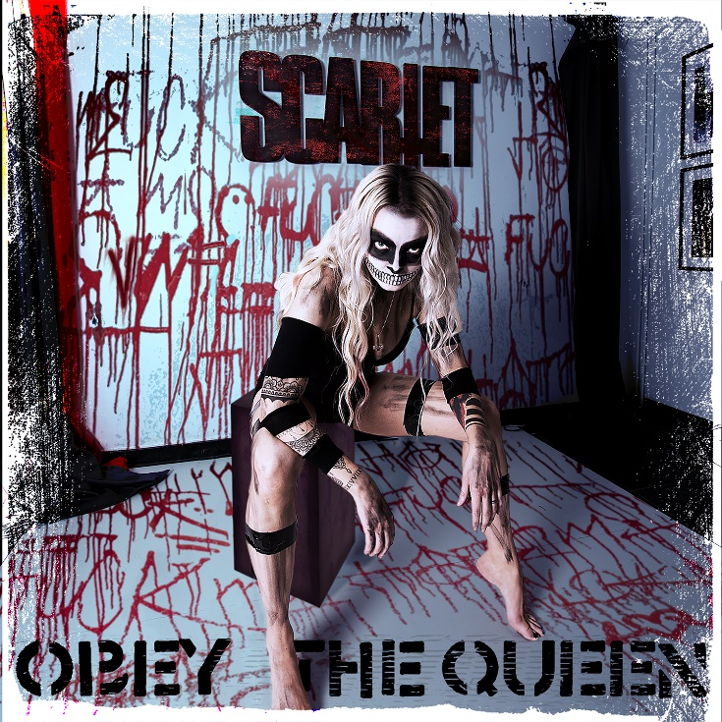

SCARLET

»Obey The Queen«

VÖ: 13.11.2020

Line Up:  Line-up: | SCARLET online:
Scarlet | Vocals | www.scarlethunts.com  www.facebook.com/scarlethunts  www.instagram.com/scarlethunts

Das Album »Obey The Queen« zeigt einwandfrei die Komplexität und Dualität von Scarlets Wesen. Ihre äußere Schönheit und ihr inneres Chaos. Ihre Güte und ihr Übel. Ihre Vergebung und ihr Geschmack für Blut. Sie ist eine wunderschöne Kreatur, die die dunkelsten, hässlichsten Ecken des menschlichen Geistes verkörpert, und Sie ist niemals die, für die sie Sie halten.
„Als ich dieses Album gemacht habe, musste ich tief in den dunkelsten, schmerzhaftesten Ort in mir gehen. Graben durch Erinnerungen, die hinter Dornenwänden verborgen sind. Unbury Jahre gequälter Wut. Es hat mich fast umgebracht. Durch das Überleben kommt Größe. Ich möchte, dass diese Platte die Menschen dazu inspiriert, sich selbst zu sein. Frei leben. »Obey The Queen« ist ein Zeichen in der Geschichte. Eine Weltherrschaft. Es ist jetzt eine neue Welt. “

Jedes Lied auf dem Album zeigt eine Zeit oder Situation der Veränderung im Leben von Scarlet. Sie schreibt meistens allein in ihrer Villa im kalten Norden, aber bei einigen der Songs wie ‘#bossbitch’ und Beauty & Beast’ hat sie sich mit Schwedens berühmtesten Songschreibern des Genres zusammengetan.
Scarlet erzählt uns von den Songs auf dem Album:

‘Obey The Queen’
World Domination
“I've seen the world and its cruelties. People fighting and dying trying to obey structures and rules
created by men. It's time for a new world order… MY world order.
The title song of the album »Obey The Queen« is an anthem for the new world.”

‘I Spit Fire’
Birth
“This song is a portrait of how a small fragile bird turn into the fire spitting dragon it always was meant to be. Society sculpture us in hard concrete and steel our voices. If a bird turns into a dragon -
Concrete can turn into ashes.”

‘Ugly Fucker’
Fuck off
“So many men in social media takes the liberty of sending me pictures of their genitalia, film clips of
them touching themselfs or when they are in a sexual activity with another person. They write to me
describing what they want to do with me in bed. They tell me what I want sexually and that they will
give me the ride of my life. This song is a BIG FUCK YOU to all these people! You will NEVER be
enough to satisfy my desires.”

‘#bossbitch’
Domnation
“When I show strength they call me a bitch. When I speak my mind, they call me a bitch. When I build
a successful business, they call me a bitch.
This is an anthem to every women, every mother, every sister, female business leader, single parent
and independent women. To all the ladies who fights everyday in a world build by privilege men for
privilege men. The only purpose off #bossbitch is to promote female empowerment.
Yes. I'm a bitch. A BOSS BITCH. So step the fuck aside.”

‘Love Heroin’
Love
“We love, we die” Love is nothing but pain and survival. Once you have had the taste of love you will
never again settle for anything less. That is an unresolved equation. You will live your life knowing that the taste of happiness is an illusion created by fools.”

‘Zodiac’
Hunt
“When the hunter becomes the prey, the game has changed. When you have nothing to lose and your mind is set to destroy you win every price you set your eyes on. I will find you. Always.”

‘Krokodil’
Death
“For a time in my life I lived in Russia. The streets were crowded with people trying to survive. Besides the wealthy overeaters, poverty and darkness ruled the country. Krokodil is a portrait of a power killing its own by the edge of a needle.”

‘Beauty & Beast’
Duality
“I have a monster inside of me. A beast that I fight everyday to tame. I love it and I hate it. It is a part ofme that I can't live neither with or without. With acceptance comes some kind of peace. If I welcome my darkness, It won't hurt me. This song is a reminder of that all that is inside of us, how scary it might be, is a part of us and we can learn to live with it if we treat it with love.”

‘Devil Twins’
Revenge
“All my life I have been driven by one very strong force. That force is revenge. If your force is pure evil, I will hunt you down and destroy you. Torture you and enjoy every second of it. I will hurt you, with all means necessary.”

‘Final Shot’
Hope
“This is my interpretation of one of the best songs ever written, “Total Panik” by Swedish hard rock
band “Lillasyster”. Since I started to accept what I can not change, accept that pain can coexist with happiness and that you set the rules of your own life, it's easier to live. It doesn't have to hurt. And when it hurts, you are just alive.”

